____________________________________________________________________________

Status of code / additional notes
Points / descriptions to check
Priority to check
Choice (to re-visit later or after writing code in full)
Checks
Code snippets

____________________________________________________________________________

START OF PROGRAM:

Imports:
- numpy
- matplotlib.pyplot
- matplotlib
- from preliminaries, SLN, CC3, load_results_Isatis
- from isatis_reproduction, read_blackhawk_spectra

____________________________________________________________________________

Understand at which mass range secondary emission of photons from PBHs becomes significant

Plot the primary and total photon spectrum at different BH masses.

- Create array of PBH masses, to match the range calculated for “GC_mono_…” calculations in BlackHawk (or m_pbh_mono appearing in isatis_reproduction.py)
  - m_pbh_values = np.logspace(11, 21, 1000)

- Choose indices to plot
  - E.g. indices = [201, 301, 401, 501]

- Create figure

- Loop through indices
  - Find corresponding PBH mass
  - Load primary spectrum and secondary spectrum
  - Plot primary and secondary photon spectrum

NOTES:
- The x-axis range is chosen to approximately match the range of energies that are constrained by observations from INTEGRAL, COMPTEL, EGRET and Fermi-LAT (see Fig. 2 of 2201.01265):
  - Upper range is 5 GeV, since Hazma tables are not defined for E > 5 GeV. However, there are constraints from Fermi-LAT up to ~30 GeV.

Plot the integral over the PBH spectrum, for each PBH mass

- Create empty lists called integral_primary and integral_secondary

- Loop through PBH masses
  - For each mass, load photon spectrum (primary and total)
  - Estimate the integral of the photon spectrum over the energy range (1e-6, 5) GeV using np.trapz(), for both the primary spectrum only and total spectrum
  - Append these values to integral_primary and integral_secondary, respectively

- Plot integral_primary and integral_secondary

- Plot m^{-1} dependence?
  - Yes

Plot the integral of E * PBH spectrum, for each PBH mass

- Create empty lists called integral_primary and integral_secondary

- Loop through PBH masses
  - For each mass, load photon spectrum (primary and total)
  - Estimate the integral of the photon spectrum over the energy range (1e-6, 5) GeV using np.trapz(), for both the primary spectrum only and total spectrum
  - Append these values to integral_primary and integral_secondary, respectively

- Plot integral_primary and integral_secondary

- Plot m^{-2} dependence?
  - Yes

Results (19/3)

From this plot, indicates that secondary emission of photons is non-negligible even at M_PBH = 1e17g (at E <~ 1e-4 GeV, in the range sensitive to INTEGRAL observations).

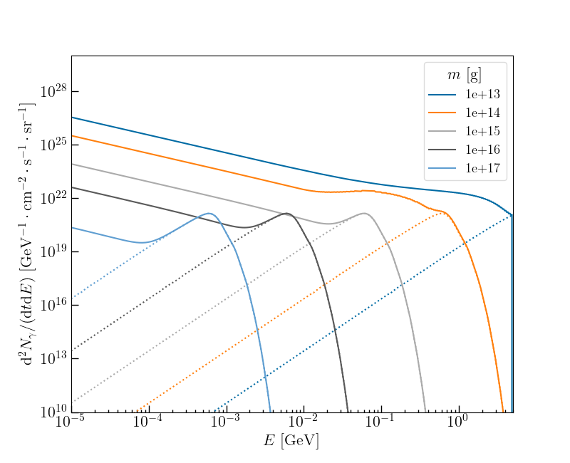
The effect of secondary emission is much stronger for smaller PBH masses, and is especially noticeable for m < 1e15g, when the shape of the spectrum is noticeably different, with a less pronounced peak.

In the following plots, I am showing the spectrum integrated over energy, and the spectrum * energy integrated over energy.

In both cases, the result including the primary photon spectrum only is well-approximated by a power-law for masses between ~1e13 – 1e19g.
- One possible cause is the limited energy range for which the spectrum is calculated.
  - From Eq. (2.1) of 1604.05349, kT = 0.106 (m / 1e14g)^{-1} GeV
    - m = 1e13g, kT ~ 1 GeV
    - m = 1e19g, kT ~ 1e-6 GeV
  - This range approximately corresponds to the range of energies for which I am computing the primary spectrum of photons.
- A way around this would be to compute the primary spectrum at a wider range of energies.

These results show that the mass-loss rate is not equal to the quantity appearing in Eq. (11) of 2201.01265.
- In Eq. (11), there is an integration over d \Phi / dE, which is defined in Eq. (7) of 2201.01265, with Q~ given by Eq. (6) of 2201.01265.
- Eq. (3) of 2201.01265 gives the mass loss rate, which differs from Eq. (6) of 2201.01265 due to the factor of E appearing in the integration
- Conceptually understand why we are interested in Eq. (7) for the photon constraints, rather than the mass-loss rate

The first plot is equivalent to Eq. (6) of 2201.01265, which appears in the integrand when calculating the constraint from Galactic Centre photons.
The second plot is equivalent to Eq. (3) of 2201.01265 (the mass-loss rate from a PBH).
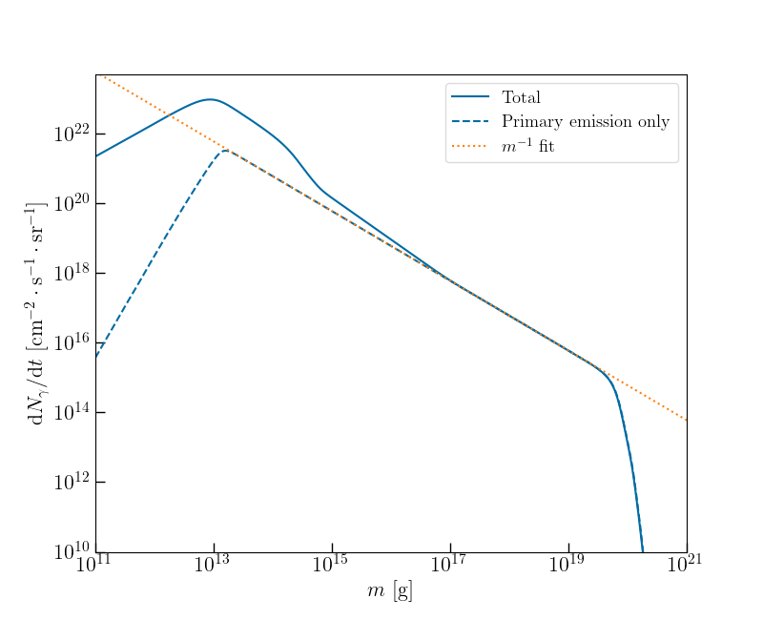

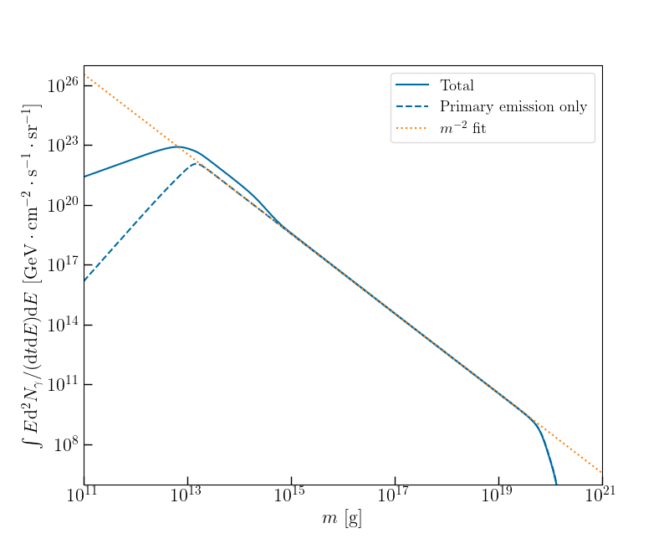
Understand the effect of evaporation on the PBH MF, and on X(m).

